**Neural Networks and Deep Learning**

**by Andrew Ng**

**Contents:**

1. Neural Networks and Deep Learning
2. Improving Deep Neural Networks: Hyperparameter tuning, Regularization and Optimization
3. Structuring your ML project
4. Convolutional Neural Networks
5. NLP: Building sequence models (LSTM, RNN)

**Lec 2: What is a Neural Network?**

Consider the case of house price prediction. We fit a line in linear regression to determine price against size of the house. In neural network the neuron performs this function.

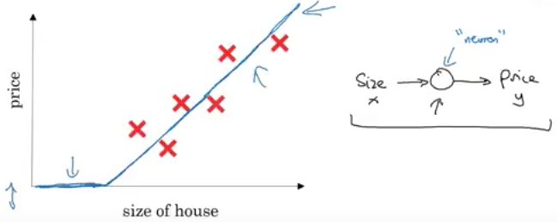

For predicting house price with more than one feature:

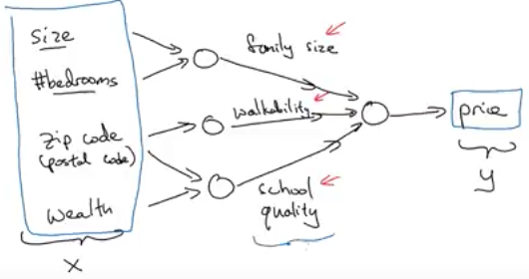

For neural networks to work, providing input and output is alone sufficient. It figures out the hidden layer by itself by taking all input features to one neuron. It performs really well given large number of training example.

**Lec 3: Supervised Learning with Neural Networks**

Most neural networks are based on supervised learning where both input and output are fed. CNNs for images, RNN for sequence data, standard neural networks for classification/regression and custom/hybrid neural networks for more complicated applications.

Some neural network examples:

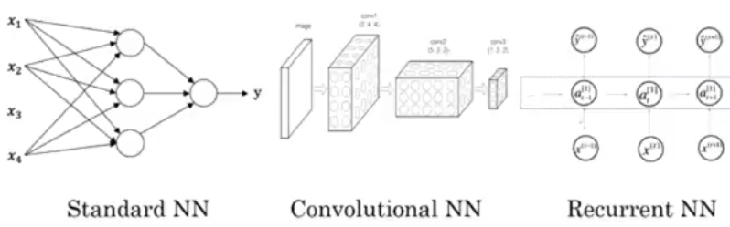

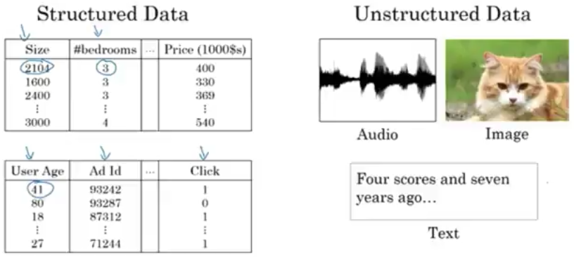

**Lec 4: Drivers behind rise of Deep Learning**

Over recent times, deep learning has scaled up with larger neural nets (deeper layers and more neurons) and with lots of labeled data to train on.

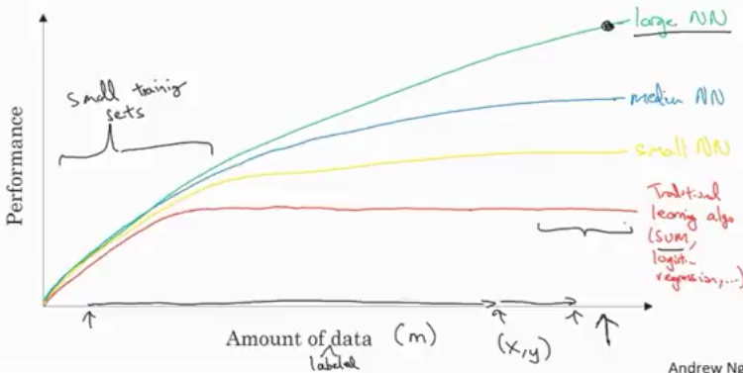

Considering the portion of graph where there are lesser training sets, the performance of any algorithm depends heavily on feature engineering. So any algorithm can perform well.

Apart from data and computation, algorithms have played a major role as well. For example, switching over from sigmoid function to ReLu activation function helps gradient descent perform learning much faster

Computation plays a big role because mostly NNs are run by trial and error in the cycle of idea -> code -> experimentation and back to idea again.